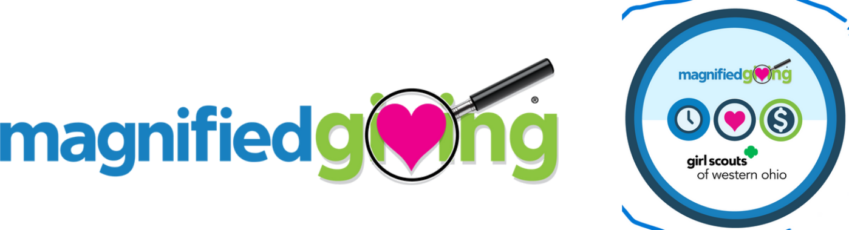

Earn the Magnified Giving Patch!

About Magnified Giving

The vision of Magnified Giving is for every youth in America, starting with the Greater Cincinnati and Northern Kentucky regions, to someday have the opportunity to learn first-hand how to be generous and wise philanthropists and have the graduates of the program educate, inspire, and engage the next generation of students. Our mission is to educate, inspire and engage students in philanthropy, and to touch the hearts and minds of teens, lighten the concerns of others, and magnify the impact of philanthropy.

Cadette, Senior, and Ambassador Girl Scouts can Discover, Connect, and Take Action to earn the Magnified Giving Patch by completing the following requirements:

- Discover what it means for an organization to be considered a non-profit and the different social causes non-profit organizations (NPOs) by researching local non-profits using the Magnified Giving Qualified NPOs Page.
- Go further by filling out the Magnified Giving Research Guide to learn more about what the NPO stands for and how they impact their local community.
- Connect by visiting a non-profit organization to learn about their mission and take part in a service project to further the NPO’s impact on the community. Do this step as a troop or take part in a Community Impact Meetup event through GSWO!
- After completing step 3, Take Action by developing a presentation on why that NPO should receive a $1,000 grant and present your pitch at the Magnified Giving Presents: Community Impact Meetup Summit event on April 17, 2025!

Questions or requests for additional information can be sent to Alison Kaufman at alison@magnifiedgiving.org.
Magnified Giving Research Guide

Directions: You may have had the opportunity to visit and learn about a nonprofit organization through a Girl Scout Community Impact Meet-up. This worksheet will be used to help you recall what you have learned and help you to learn more. Utilize the resource suggestions provided to complete the questions below to the best of your ability.

Resources: Utilize the Magnified Giving Qualified NPOs Page, look up an organization’s name. You can scroll through the list or sort alphabetically.
Want more information about the organization not found on the Qualified NPO page? Google the agency's website directly.

Purpose: This worksheet will help you develop the talking points to be used as you advocate on behalf of the NPO you volunteered with or are interested in supporting.

Name of Non-Profit Organization:

Date Founded (when did the organization begin their mission):

What is their mission statement or purpose?

Utilizing the Magnified Giving Qualified NPO page, what social cause does this organization’s mission support?

How does this organization make an impact on the identified social cause? What do they do to support the community? Be specific.

What types of programs do they offer through the organization that is supporting the community? Why do you feel these programs are needed now and are important for those they are supporting? Be specific.

With this question, consider the population the organization is helping. Identify how many people or animals the organization is supporting each year. Be specific.

What else do you want to know about this organization? Consider what you already know and what else you’d like to know. Talk to your group members to ask their thoughts! (i.e., what is their budget, how many PAID employees do they have, can youth volunteer?)
State your questions and then provide the answers (if possible).

Consider the Girl Scout Mission, Promise and Law. Why is serving this organization important, and how does it fulfill the G.S. Mission, Promise and Law?

The information you have learned through your research and time visiting/volunteering with this organization will help you with the final stage of the Magnified Giving Patch Program. Remember, your goal is to advocate on behalf of this organization.

