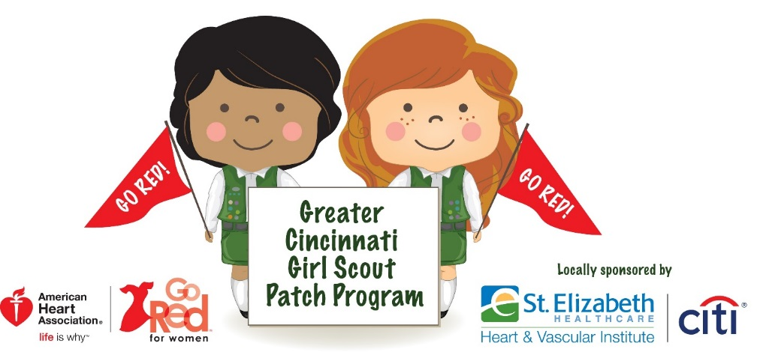

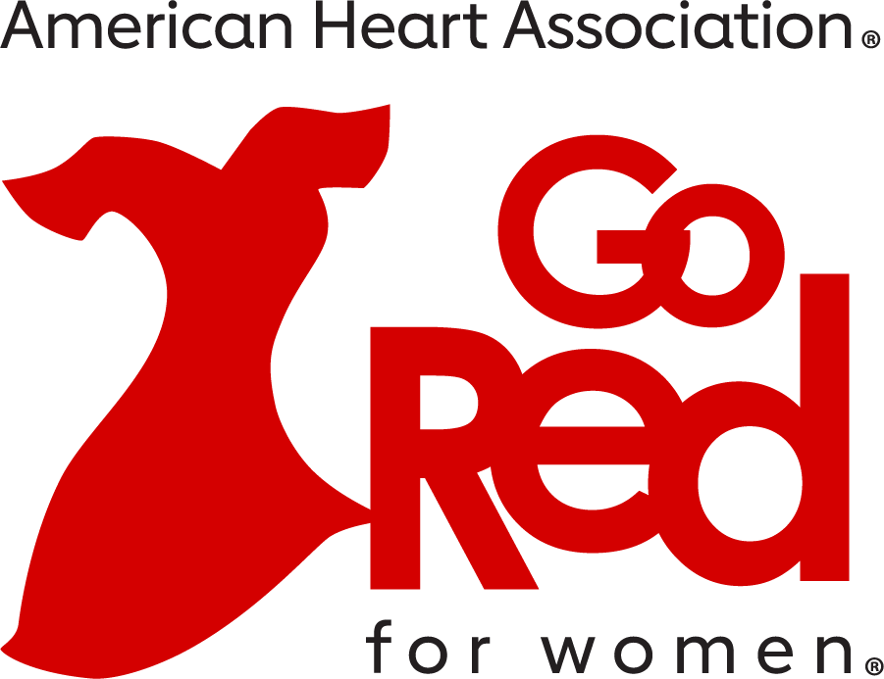

JOIN US AND EARN THE GO RED PATCH!
Go Red Girl Scout Patch Program
* Interactive Workshop Experience *

What: St. Elizabeth Healthcare, Citi and the American Heart Association will host
a free and FUN Go Red Girl Scout Patch Workshop that will allow Scouts to earn their patch.

When: Saturday, March 9, 2024 (Juniors, Cadettes, Seniors and Ambassadors)
Time: 8am – 12Noon
Where: St. Elizabeth Healthcare
711 Florence Wormald HVI Bldg,
711 Medical Village Dr, Edgewood, KY 41017
Sponsors: St. Elizabeth Healthcare and Citi

How: Register your troop by contacting Jenny Hobbs at the American Heart Association at 513.699.4240 or email jenny.hobbs@heart.org

