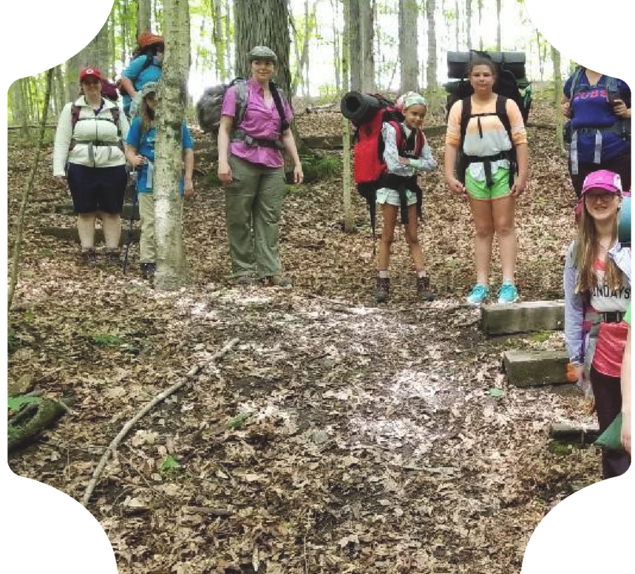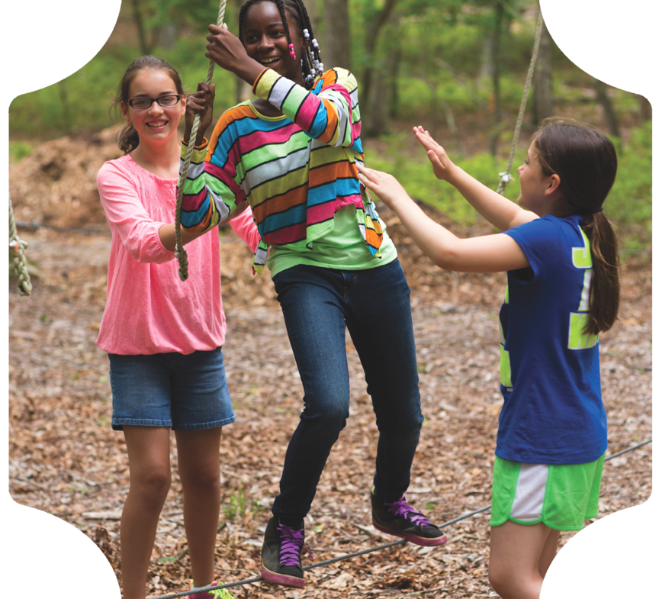

**Seven Wonders of the World**

**Hickory Hill Camp 2C**

Seven Wonders of World

June 3-7, 2024

Hickory Hill 9:00 a.m.-3:00 p.m.

Forms due by Saturday

April 20, 2024

**Questions?**

**Contact:** Cathy DeZarn, Camp Director at 513.922.4141 or [hickoryhillcamp@gmail.com.](mailto:hickoryhillcamp@gmail.com)

In Partnership With:

888.350.5090 | gswo.org



®

[customercare@gswo.org](mailto:customercare@gswo.org)



## Dear Caregiver:

Thank you for your interest in sending your Girl Scout to volunteer day camp! At day camp, girls will Discover, Connect and Take Action as they learn to live the Girl Scout Law and make a difference in the world. They will discover their values and talents through a variety of outdoor activities. Girls will also connect with other girls and adults, learn how to work together as a team and use that teamwork to take action and make the world a better place.

We hope you will see the value in this progressive opportunity, and will help keep the history and tradition of the day camp alive by volunteering at camp with your Girl Scout. Volunteer day camp is run by a dedicated team of specially trained volunteers who work year round to make this enriching opportunity possible. Volunteer day camps are staffed completely by volunteers, so we welcome moms, dads, aunts, uncles, grandparents and other adult friends to volunteer. A background in Girl Scouting is not necessary. Volunteers are asked to complete a volunteer application and background check, and attend training to prepare for your role at camp. ***Training is mandatory for all volunteers.* The training date will be in May.**

For continued progressive opportunities in Girl Scouts, we also offer many other outdoor and camp opportunities listed on our website at [**gswo.org.**](http://www.girlscoutsofwesternohio.org/)

Below you will find basic information about day camp. Detailed information and instructions will be sent in an email after you have registered about 1 week before camp. For additional questions or concerns, please contact Cathy DeZarn, Camp Director, at 513.922.4141 or [hickoryhillcamp@gmail.com.](mailto:hickoryhillcamp@gmail.com) Email is best.

**Transportation:** Transportation will be the responsibility of the caregivers to and from bus stop. Transportation will be provided by bus and is not optional. Pickup and drop off will be at Rapid Run Middle School. AM drop off 815 and PM pick up 315.

**Directions to camp:** Camp is located in Delhi. All participants are bused to location.

**Health:** A nurse or first aider will be available at camp. Check with your physician to see if a tetanus booster or any immunizations are necessary. Medications are the responsibility of the caregiver. Please give any medications your daughter may need to the health supervisor or unit leader in the original container on the first day of camp. Be sure to include written instructions. Please ensure any allergies or dietary restrictions are recorded on your Girl Scout’s Health History form and pointed out during check in.

**Food:** Everyone is to bring a sack lunch, water to drink and a cup or water bottle daily unless otherwise notified.

**Clothing:** Proper dress for the weather is necessary. No halters or sandals. Wear sturdy shoes, socks and head cover and bring rain gear. Camp is not cancelled because of rain, only severe weather.

**Insurance:** Every registered Girl Scout and registered adult member is automatically covered under the basic plan by Girl Scouts of the USA. This plan is effective from October to the following October. This insurance provides up to a specified maximum for medical expenses incurred as a result of an accident while a member is participating in an approved Girl Scout activity, after the individual’s primary insurance pays out.

**Caregivers:** If you feel this camp is unsafe or a hazard to children you should contact **Hamilton** County Children's Services Department at (241-kids).



## Activity Costs:

COST includes program, patch, t-shirt and transportation for all Girl Scout campers.

Boys/Pixie (t-shirt not included but may be purchased for $10) $ 0 Girl Scout Daisies/Brownies (Grades K–3) t-shirt included $ 70

Girl Scout Juniors (Grades 4–5) t-shirt included $ 70

Girl Scout Cadettes (Grades 6-7) t-shirt included $70 Girl Scout Program Aide Training (Grades 7-12) t shirt included $ 70

PA (grade 8-12) Must have been trained by council or camp previously $35 (t-shirt included)

Cost of Girl Scout of full-time volunteer (five days) $ 35

Membership fee for non-registered girls and adults (Must register online) $ 25 *(All girls and adults participating in camp must register as Girl Scouts.)* **Optional:** T-shirts for volunteers, pixie or boy attending $10

Make checks payable to Girl Scouts of Western Ohio. Complete the registration, additional information and release forms and return with payment to: **Lori Thai, 5808 Countryview Terrace Cincinnati, OH 45233**. If dropping off, place in mailbox by front door, not street. **DO NOT** send registrations to Girl Scout Center. All registrations received at the Girl Scout Center will be forwarded to the appropriate day camp on a weekly basis and may cause your child to be closed out of camp.

**Financial Assistance:** Financial assistance may be available for girls who want to attend but are unable to do so because of limited family income. Applicants must pay at least $35 (50 percent) of the day camp fee. Please include payment for the total amount your family can pay with the registration form. Optional T-shirt cost cannot be paid for with financial aid.

**Refund Policy:** Money may be refunded for the following reasons only:

1. Moving out of town.
2. Illness or exposure to a communicable disease.
3. Required attendance at summer school.
4. Camp capacity is reached and no other camp is attended; refund will be sent within four weeks of end of registration.

To request a refund send a written request within ten business days from the end of camp to: Cathy DeZarn

276 Anderson Ferry

Cincinnati, OH 45238



**Camper Registration Form**

**Please Print Neatly**

Camper’s Name: Phone: Address: City: State: Zip: School: Grade in Fall 2024: DOB: Age: Caregiver’s Name: Phone: Caregiver’s Email:

Troop Leader’s Name or Troop #: Service Unit Name or #:

**Units: Please mark choice of unit for child**

❑ Boys (only children of volunteers) will be available pending adult leader

❑ Girl Scout Daisies (Grade K–1)

❑ Girl Scout Brownies (Grades 2–3)

❑ Girl Scout Juniors (Grades 4–5)

❑ Girl Scout Cadettes (Grades 6) (7-8 if not interested in PA in training)

❑ Program Aide (Grades 8 and up) already trained

❑ I have taken or intend to take Program Aide Training. Date:

❑ Girl Scouts PA in training must be grade 7 or higher (will be held based on interest and staff availability)

❑ Pixies (preschool–only children of volunteers) must be potty trained and pending unit leader available

Unit (**NOT BUS**) Buddy’s Name:

T-Shirt Sizes:  Girl OR  Adult  SM  MED  LG  XL **(Be sure to indicate Girl or Adult size)**

Bus stop is Rapid Run Middle School (Times 815/315 approximately)



❑ I give full permission for my daughter/son to attend day camp and participate in all phases of activities, except those noted. I have read the Day Camp flier and agree to cooperate with the guidelines listed. I understand that my camper must have written permission to leave camp early or with someone other than a caregiver. If I cannot be reached in an emergency, I give permission to give emergency treatment to my child.

Caregiver Signature: Date:

**Mail completed Registration form, Additional Information, Release and Health Form and Photo Release with fee to:**

|  |  |
| --- | --- |
| **TOTAL FEES** | |
| Girl Day Camp Fee (includes T-shirt) | $ |
| PA (already trained) | $ |
| Pixie or boy T-shirt (optional $10) | $ |
| Cookie Dough must be turned in by May  31 (cannot be used for optional T-shirt | $ |
| Financial aid requested | $ |
| **TOTAL PAID** | $ |

Lori Thai

5808 Countryview Terrace

Cincinnati, OH 45233

Registrations will be accepted until APRIL 20. Girls will be accepted on a first come, first served basis based on the number of volunteers available and according to postmark. **Priority** will be given to girls with caregivers who are volunteering.





**Additional Information, Release and Health History Form**

Camper’s Name: Date of birth: Age:

Address:

Caregiver’s Name: Phone:

Caregiver’s Email:

# Transportation Information

I understand that my daughter will only be released to the people listed below with proper ID:

|  |  |  |
| --- | --- | --- |
| Name | Relationship to girl | Phone # |
| Name | Relationship to girl | Phone # |
| Medical Information |  |  |

This section **must** be completed by all girls and adults attending in order to register for camp. Name DOB

Are medications currently being taken:  No  Yes, please specify: (below)

(Medication must be in original container with written instructions and given to the health supervisor at camp.)

Are there any special needs or accommodations required? If yes, please explain: (below)

Are there any known behavior and/or emotional problems? If yes, please explain: (below)

Allergies and/or dietary modifications:



Is participant in good physical condition with no serious illness or operation since last health exam?

❑ Yes  No If no, please specify:

Physician’s Name: Phone #:

**Insurance Information:**

Is the participant covered by family medical/hospital insurance? Yes No



❑



❑

If so, indicate carrier or plan name: Group #:

Name of insured: Relationship to participant:

Social security number of policyholder or insurance ID number:

**Emergency Contact Information**

Emergency contact in case we can’t reach caregiver:

Name

Relationship to girl

Caregiver Permission and Consent to Treatment

Phone #

(Name of participant) is in good physical health and has had a physical examination in the past 12 months. Participant has my permission to attend Girl Scout day camp and to participate in all activities except those noted. I have read the day camp flier and understand and agree to cooperate with all regulations. I further understand that the deposit is refundable only for the reasons noted on the flier.

**Emergency Medical Authorization:** This health history is correct to the best of my knowledge, and the person herein described has permission to engage in all prescribed Girl Scout activities except as specifically noted.

**Authorization for Treatment:** In the event reasonable attempts to contact me at the provided phone numbers have been unsuccessful, I hereby give my consent to the administration of emergency medical treatment by any licensed physician or dentist and to transfer the child to any reasonably accessible hospital facility. This authorization does not cover major surgery unless the medical opinions of two other licensed physicians or dentists, concurring in the necessity for such surgery, are obtained prior to the performance of such surgery.

My daughter may be registered as a Girl Scout member through September 30, 2024.

Caregiver Signature: Date:

05-10238-02/2022

**Release Form ‐ Minor**

***Photo Release***

***For Minors***

**Date(s):**  Monday‐Friday, June 3-7, 2024 **Photographer/Producer:**  Girl Scouts of Western Ohio **Assignment:**  Camp 2C Seven Wonders of World **Location:**  Hickory Hill Camp **Activity:**  Camp is a great way for girls to explore leadership, build skills and develop a deep appreciation

for nature.

For good and valuable consideration, the receipt and sufficiency of which are hereby acknowledged, I hereby consent and agree to the following:

1. I hereby grant to Girl Scouts of Western Ohio, and others working for Girl Scouts of Western Ohio or on its behalf, and each of its respective licensees, successors and assigns (each a “Releasee”), the irrevocable, royalty‐free, perpetual, unlimited right and permission to use, distribute, publish, exhibit, digitize, broadcast, display, modify, create derivative works of, reproduce or otherwise exploit my name, picture, likeness and voice (including any video footage of the same) (collectively, “Media”), or to refrain from so doing, anywhere in the world, by any persons or entities deemed appropriate by Girl Scouts of Western Ohio, for any purpose (except defamatory) including, without limitation, any use for educational, advertising, non‐commercial or commercial purposes in any manner or media whatsoever (whether known or hereafter devised) including, without limitation, on the internet, in print campaigns, in‐store and via television. I agree that I have no interest or ownership in any of the Media.
2. I shall have no right of approval, no claim to compensation and no claim (including, without limitation, claims based upon invasion of privacy, defamation or right of publicity) arising out of any use, alteration, blurring, illusionary effect or use in any composite form of my name, picture, likeness and voice. I agree that nothing in this Release will create any obligation on Girl Scouts of Western Ohio to make any use of the Media or the rights granted in this Release. I hereby release and hold harmless Releasees from any claim for injury, compensation or negligence resulting or arising from any activities authorized by this Release and any use of the Media by Girl Scouts of Western Ohio.

Name of Minor (please print): Address: City: State: Zip: Daytime Phone Number: ( ) Additional Phone (optional): ( )

Release for minors (those under the age of eighteen): I, the undersigned, being a caregiver of the minor, hereby consent to the foregoing conditions and warrant that I have the authority to give such consent.

Name of Caregiver (please print): **Signature of Caregiver (Required):**  Date: _______Relationship: __________________ Caregiver Email Address*: @

*(*will not be used for any other purposes or distributed to third parties)*

Region: Troop#: Service Unit:

05‐9001‐02/2022





**Adult Volunteer Form**

**We need your help!** Our day camp is staffed entirely by adult volunteers. A Girl Scout background is not necessary**.** Training, which will prepare you for your role at day camp, is mandatory**.** Childcare is available at a nominal fee for our adult volunteers while they are at camp. Your non-Girl Scout children, ages 2 (toilet trained)–12, may attend camp in their own units. Children of unit leaders working three to five full days will receive a reduced rate on their day camp fees.

All unit leaders must complete this form, as well as the Adult Registration, Health History and Photo Release forms found in this packet. You will be asked to complete a Girl Scouts of Western Ohio Volunteer Application, a background check and become a registered member of Girl Scouts if you are not already an approved Girl Scout volunteer.

**Ways adults can help:**

* Adults are needed as unit leaders. Unit leaders will have fun with girls, while taking part in exciting camp activities some that are pre-planned by administrative staff volunteers. They will also have the opportunity to assist girls in decision making, as campers plan their unit activities for the week. Unit leaders must attend training, which will prepare them for their role at camp (see below). Priority registration is provided to children whose parent/caregiver volunteers as a unit leader all week.
* We also need administrative help and part time first aider. (Nurse, EMT, Physician)
* MOST IMPORTANTLY WE NEED HELP WITH CAMP CLEAN UP

Camp clean-up will start in late April/May (most weekends) Final clean up will be memorial day weekend (weather permitting). Anyone available with the ability to cut a large meadow, please contact camp director. We need help clearing trails. Bring rakes, shovels, chain saw, gloves, etc.





**Adult Registration Form Seven Wonders of World 2C**

**June 3-7, 2024**

Volunteer’s Name:

Phone:

Address:

City:

State:

Zip:

Email Cell Phone:

Are you a registered Girl Scout?  Yes  No Are you a leader/assistant leader?  Yes  No Troop #: Troop Grade Level in Fall: Service Unit Name/#:

- **or** -

❑ Check box if not currently registered as a Girl Scout. All adults must be registered as Girl Scouts to attend day camp. (Please register online at www.gswo.org) Directions will be given on completion of background check.

Please indicate what level/unit you would like to work with Adult I would like to work with _____________________

I want to be with my daughter Yes No (please circle choice) If multiple daughters which one

-----------------------------------------------------------

**T-Shirts:** Shirts cannot be returned or exchanged. If in doubt, order the next larger size. T-shirts are optional.

Adults working who want a T-shirt, should send $10 with their camp registration.

**Sizes:** Adult:  Small  Medium   Large  X-Large  XX-Large  XXX-Large

**Bus stop:**

Rapid Run Middle School. (8:15/3:15)

Registrations will be accepted postmarked until **April 20, 2024**. Please send in as soon as possible to ensure placement. **Do not send camp registrations to the Girl Scout Center. Mandatory training May 3rd St. Dominic O’Connor Hall 630pm.**

**Mail completed Adult Registration Form, Adult Medical History Form and Photo Release with fee**

|  |  |
| --- | --- |
| **TOTAL FEES (payable to GSWO)** | |
| Adult T-shirt (optional $10) | $ |
| **TOTAL** | **$** |

**(if applicable) to: Lori Thai**

**5808 Countryview Terrace**

**Cincinnati, OH 45233**





**Adult Medical History**

Name _____________________________________ Phone ________________________

Address____________________________________ City ______________________ State _______ Zip _________

Email_________________________________________

Physician Name __________________________________ Phone_____________________

Dentist Name ____________________________________ Phone _____________________

Insurance company ___________________________ Insured Name __________________________

Group # _________________ ID# _______________________

**Emergency Contacts:**

Name _____________________________________________ Relationship to Participant _______________________

Address _____________________________________ City ___________________ State ______ Zip _____________

Home phone ____________________ Cell phone ___________________ Work phone _____________________

Please list any conditions that a first‐aid or health provider would need to know.

Allergies:

Medications currently taking:

Chronic illnesses, injuries, or limitations:

**My Immunizations are up to date:**  Yes  No

In the event that reasonable attempts to contact my designated person in an emergency have not been successful, I hereby give my consent for the administration of any treatment deemed necessary by medical personnel. This health history is complete and accurate.

Signature __________________________________________________ Date _______________





**Release Form ‐ Adult**

***Photo Release***

***For Adults***

**Date(s):**  Monday‐Friday, June 3-7, 2024 **Photographer/Producer:**  Girl Scouts of Western Ohio **Assignment:**  Camp 2C Seven Wonders of World **Location:**  Hickory Hill Camp **Activity:**  Camp is a great way for girls to explore leadership, build skills and develop a deep appreciation

for nature.

**RELEASE FOR ADULTS**

For good and valuable consideration, the receipt and sufficiency of which are hereby acknowledged, I hereby consent and agree to the following:

1. I acknowledge that I am eighteen (18) years of age or older. I hereby grant to Girl Scouts of Western, and others working for Girl Scouts of Western Ohio or on its behalf, and each of its respective licensees, successors and assigns (each a “Releasee”), the irrevocable, royalty‐free, perpetual, unlimited right and permission to use, distribute, publish, exhibit, digitize, broadcast, display, modify, create derivative works of, reproduce or otherwise exploit my name, picture, likeness and voice (including any video footage of the same) (collectively, “media”), or to refrain from so doing, anywhere in the world, by any persons or entities deemed appropriate by Girl Scouts of Western Ohio, for any purpose (except defamatory) including, without limitation, any use for educational, advertising, non‐commercial or commercial purposes in any manner or media whatsoever (whether known or hereafter devised) including, without limitation, on the internet, in print campaigns, in‐store and via television. I agree that I have no interest or ownership in any of the media.
2. I shall have no right of approval, no claim to compensation and no claim (including, without limitation, claims based upon invasion of privacy, defamation or right of publicity) arising out of any use, alteration, blurring, illusionary effect or use in any composite form of my name, picture, likeness and voice. I agree that nothing in this release will create any obligation on Girl Scouts of Western Ohio to make any use of the media or the rights granted in this release. I hereby release and hold harmless Releasees from any claim for injury, compensation or negligence resulting or arising from any activities authorized by this release and any use of the media by Girl Scouts of Western Ohio.

Signature: Date:

Name (please print): Home Address: City: State: Zip: Daytime Phone: ( ) Additional Phone (optional): ( )

Email Address*: @

*(*will not be used for any other purposes or distributed to third parties)*

Region: Troop#: Service Unit:

